A=0v , B=0v  Op = 5v | 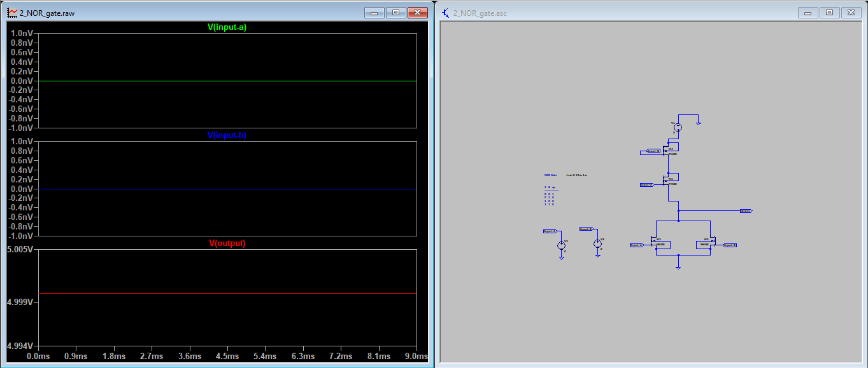
A=0v , B=5v  Op = 0v | 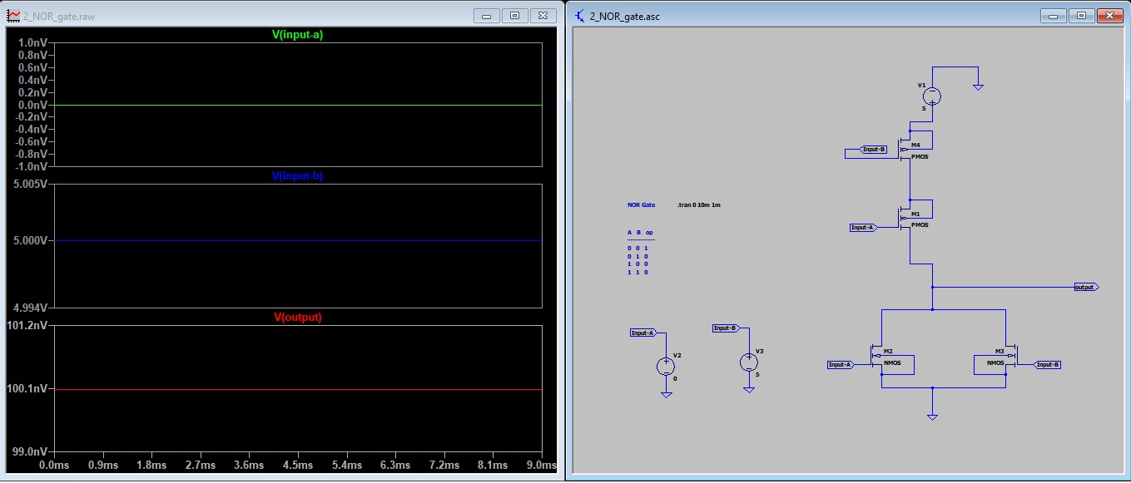
A=5v , B=0v  Op = 0v | 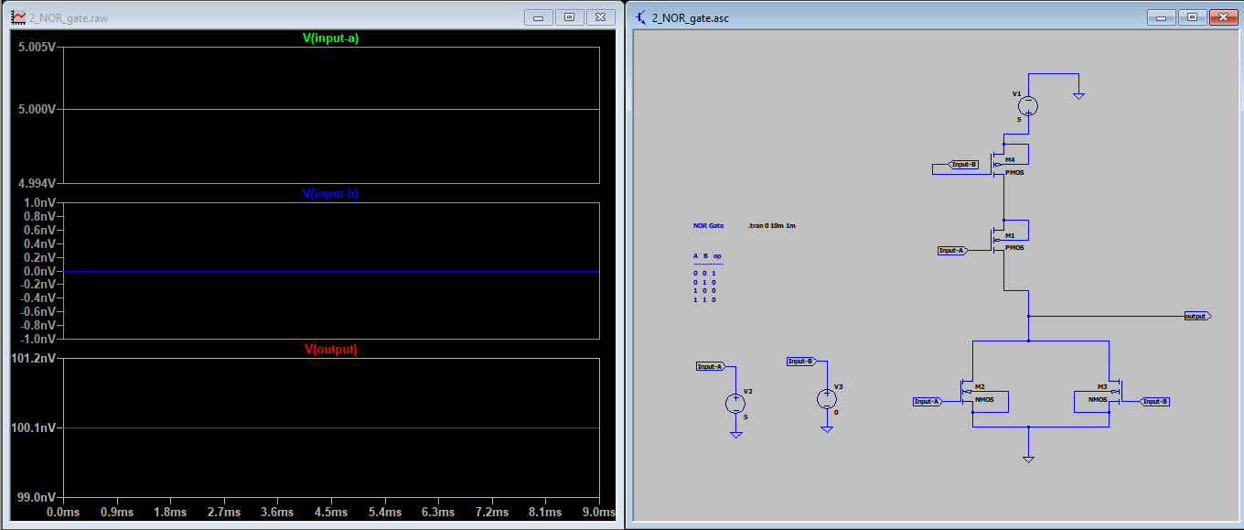
A=5v , B=5v  Op = 0v | 